# JavaScript for Front-End – DOM Manipulations

Your task is to write the Front-End part of an application which renders information into HTML.

There are a few simple tasks. Those little tasks will ultimately combine into the functionality you need for the application itself.

## Rendering Data in HTML – 80 pts

In order for the HTML to look tidy and well formed, CSS needs to be applied, which suggests some specific element hierarchy and classes. Check the template and make sure your function renders the object correctly. You can see input and output below.

Create your functions for this task inside the jquery-data.js file, and implement them so that they render the data inside the jquery-data.html file.

### Render Elements in HTML – 40 pts

#### Input

|  |
| --- |
| jquery-data.html |
| <!DOCTYPE **html**> <**html lang="en"**> <**head**>  <**meta charset="UTF-8"**>  <**title**>Title</**title**>   <**link rel="stylesheet" href="style.css"**>  <**script src="https://ajax.googleapis.com/ajax/libs/jquery/3.2.1/jquery.min.js"**></**script**> </**head**> <**body**>  <**main id="elementsContainer"**>   <**div class="container"**></**div**>  <**script src="jquery-data.js"**></**script**>  **</main**>  </**body**>  </**html**> |
|  |

#### Output

|  |
| --- |
| jquery-data.html |
| <!DOCTYPE **html**> <**html lang="en"**> <**head**>  <**meta charset="UTF-8"**>  <**title**>Title</**title**>   <**link rel="stylesheet" href="style.css"**>  <**script src="https://ajax.googleapis.com/ajax/libs/jquery/3.2.1/jquery.min.js"**></**script**> </**head**> <**body**> <**main id="elementsContainer"**>   <**h1**>Choose Your Destiny</**h1**>  <**div class="container"**>  <**div class="containers"**>  <**div id="air" class="first clickable"**></**div**>  <**div id="fire" class="second clickable"**></**div**>  </**div**>  <**div class="containers"**>  <**div id="water" class="third clickable"**></**div**>  <**div id="earth" class="fourth clickable"**></**div**>  </**div**>  </**div**>  <**script src="jquery-data.js"**></**script**>  </**main**></**body**></**html**> |

If you do everything correctly, you should see this:

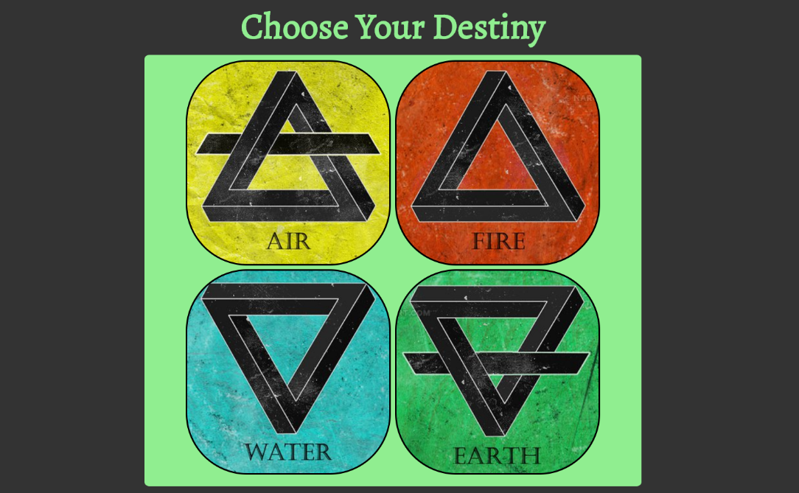

### Render Single Element In HTML – 40 pts

Render the date of single element like following:

#### Input

|  |
| --- |
| jquery-data.html |
| <!DOCTYPE **html**> <**html lang="en"**> <**head**>  <**meta charset="UTF-8"**>  <**title**>Title</**title**>   <**link rel="stylesheet" href="style.css"**>  <**script src="https://ajax.googleapis.com/ajax/libs/jquery/3.2.1/jquery.min.js"**></**script**> </**head**> <**body**> <**header**>  </**header**> <**main id="elementsContainer"**>   <**h1**>Choose Your Destiny</**h1**>  <**div class="container"**>  <**div class="containers"**>  <**div id="air" class="first clickable"**></**div**>  <**div id="fire" class="second clickable"**></**div**>  </**div**>  <**div class="containers"**>  <**div id="water" class="third clickable"**></**div**>  <**div id="earth" class="fourth clickable"**></**div**>  </**div**>  </**div**> </**main**>  <**div id="elementInfo"**>  <**h1 id="elementInfoTitle"**>Air</**h1**>  <**div class="back-button"**>    </**div**>  <**section class="second-layout"**>  <**div class="first-after-click"**>  <**ul class="creatures"**>    </**ul**>  </**div**>  <**div class="center-after-click"**>    </**div**>  <**div id="right-after-click"**>  </**div**>  </**section**>  </**div**>  **<script>src="jquery-data.js"**></**script**> </**body**> </**html**> |

#### Output

|  |
| --- |
| jquery-data.html |
| <!DOCTYPE **html**> <**html lang="en"**> <**head**>  <**meta charset="UTF-8"**>  <**title**>Title</**title**>   <**link rel="stylesheet" href="style.css"**>  <**script src="https://ajax.googleapis.com/ajax/libs/jquery/3.2.1/jquery.min.js"**></**script**> </**head**> <**body**> <**header**>  </**header**> <**main id="elementsContainer"**>   <**h1**>Choose Your Destiny</**h1**>  <**div class="container"**>  <**div class="containers"**>  <**div id="air" class="first clickable"**></**div**>  <**div id="fire" class="second clickable"**></**div**>  </**div**>  <**div class="containers"**>  <**div id="water" class="third clickable"**></**div**>  <**div id="earth" class="fourth clickable"**></**div**>  </**div**>  </**div**> </**main**>  <**div id="elementInfo"**>  <**h1 id="elementInfoTitle"**>Air</**h1**>  <**div class="back-button"**>  <**button id="backToElements"**>Back to Elements</**button**>  </**div**>  <**section class="second-layout"**>  <**div class="first-after-click"**>  <**ul class="creatures"**>  <**li**>  <**input class="radio-button checked" name="selector" type="radio" value="Archangel"**>  <**label**>Archangel</**label**>  <**input class="radio-button checked" name="selector" type="radio" value="Elemental"**>  <**label**>Elemental</**label**>  </**li**>  </**ul**>  </**div**>  <**div class="center-after-click"**>  <**img id="creature-image" src="images/archangel.jpg" alt="archangel"**>  </**div**>  <**div id="right-after-click"**>  <**p id="creature-name"**>Archangel</**p**>  <**p id="creature-power"**>Power:2000</**p**>  <**p id="creature-ultimate"**>Ultimate: Wind Justice</**p**>  <**p id="creature-region"**>Region: Heaven’s Kingdom</**p**>  </**div**></**section**></**div**>  **script src="jquery-data.js"**></**script**> </**body**> </**html**> |
|  |

If you do everything correctly, you should see this:

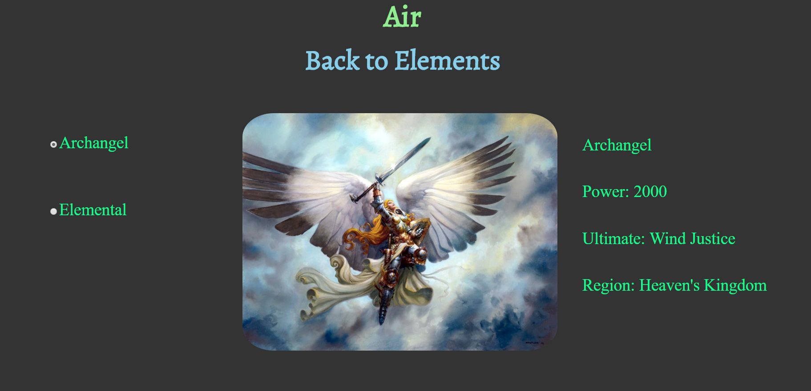

**JQuery** may be used in this problem. It is **ADVISED** that you use **JQuery**, but **native DOM manipulation** is also allowed.

|  |
| --- |
| jquery-data.js |
| **function** *renderAllElementsInHTML*(elements) {  *//****TODO: Implement me ...*** }  **function** *renderSingleElementInHTML*(element) {  *//****TODO: Implement me ...*** } |

## Capture Click Event – 20 pts

Now let’s complete some tasks of handling click events. Write your code in events.js.

### Element Click Event – 20 pts

Your task is to **attach** a click event to **#air,#fire,#water,#earth**, which hides all of the content displayed **in Render Elements in HTML**  and show all of the content created by **Render Single Element In HTML** . After click you should **RENDER** the **ELEMENT NAME** as title,**back** button, radio buttons for **all creatures** in **current element**  **picture**, and **info** about **selected creature**.